Worksheet No. 2

Student Name: ANINDITA DHAR UID: 25MCA20259
Branch: MCA (GENERAL) Section/Group: MCA- 1-A
Semester: II Date of Performance: 17/01/2026
Subject Name: Technical Training Subject Code: 25CAP-652

1.Aim/Overview of the practical:
To implement and analyse SQL SELECT queries using filtering, sorting, grouping, and aggregation concepts in PostgreSQL for efficient data retrieval and analytical reporting.

2. Objectives:
After completing this practical, the student will be able

- To retrieve specific data using filtering conditions
- To sort query results using single and multiple attributes
- To perform aggregation using grouping techniques
- To apply conditions on aggregated data
- To understand real-world analytical queries commonly asked in placement interviews.

3. Input/Apparatus Used:
- PostgreSQL
- pgAdmin

4. Practical / Experiment Steps
- Create a sample table representing customer orders
- Insert realistic records into the table
- Retrieve filtered data using the WHERE clause
- Sort query results using ORDER BY
- Group records and apply aggregate functions
- Apply conditions on grouped data using HAVING
- Analyse execution order of WHERE and HAVING clauses

4.Procedure/Algorithm/Code:

- Start the system and log in to the computer.

ii. Open PostgreSQL software.

iii. Create and select the database.

create database CompanyDB;

iv. Create a table using the DDL command.

create table customer_orders (

order_id serial primary key,

customer_name varchar(20),

product varchar(20),

quantity int,

price numeric(10,2),

order_date date

);

v. Insert records into the table named customer_orders.

insert into customer_orders(customer_name,product,quantity,price,order_date) values

('Amit', 'Laptop', 1, 55000, '2025-01-05'),

('Amit', 'Mouse', 2, 800, '2025-01-06'),

('Riya', 'Mobile', 1, 22000, '2025-01-10'),

('Riya', 'Headphones', 1, 2000, '2025-01-10'),

('Karan', 'Laptop', 1, 60000, '2025-02-02'),

('Karan', 'Keyboard', 1, 1500, '2025-02-05'),

('Neha', 'Mobile', 2, 21000, '2025-02-15'),

('Neha', 'Charger', 3, 900, '2025-02-18');

vi. Display all records.

select * from customer_orders;

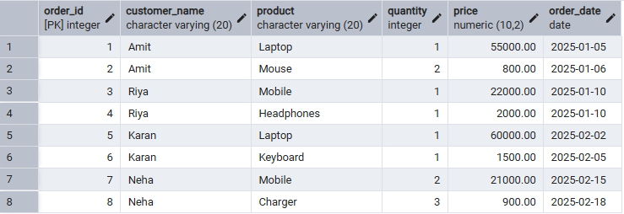

vii. Filtering table data using the WHERE clause.

select order_id, customer_name, product, quantity, price

from customer_orders

where price > 20000;

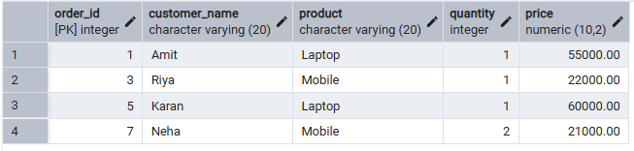

viii. Sorting Query Results.
(Ascending Order)
select order_id, customer_name, product, quantity, price
from customer_orders
where price > 20000
order by price;

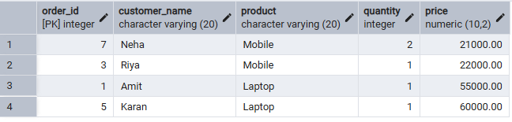

(Descending Order)
select order_id, customer_name, product, quantity, price
from customer_orders
where price > 20000
order by price desc;

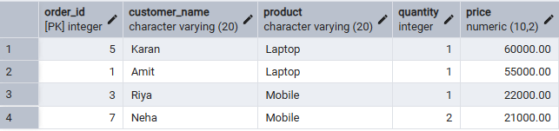

ix. Grouping Data for Aggregation.
select product, count(*) as total_product_sale
from customer_orders
group by product;

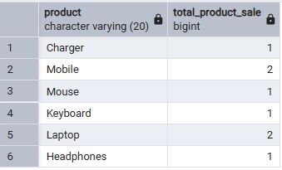

x. Applying conditions on aggregated data (HAVING).
select product,
sum(quantity*price) as total_revenue
from customer_orders
group by product
having sum(quantity*price) > 50000;

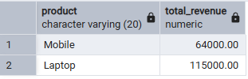

xi. Using WHERE and HAVING together.
select product, sum(quantity*price) as total_revenue
from customer_orders
where order_date >= '2025-01-01'
group by product
having sum(quantity*price) > 50000;

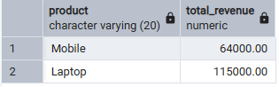

5. I/O Analysis (Input / Output Analysis)
Input:
- Customer order details
- Filtering, sorting, grouping, and aggregation queries
Output:
- Filtered customer records
- Sorted result sets
- Group-wise sales summary
- Aggregated revenue reports
(Screenshots of execution and output attached)

6. Learning Outcomes:
- Students understand how data can be filtered to retrieve only relevant records from a database.
- Students learn how sorting improves the readability and usefulness of query results in reports.
- Students gain the ability to group data for analytical purposes.
- Students clearly differentiate between row-level conditions and group-level conditions.
- Students develop confidence in writing analytical SQL queries used in real-world scenarios.
- Students are better prepared to answer SQL-based placement and interview questions related to filtering, grouping, and aggregation

